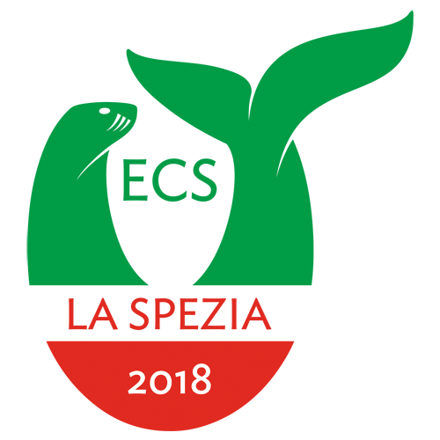

European Cetacean Society • The 32nd Conference
April 6th to April 10th 2018

Student grant registration form
Due to the uncertainty about the final budget of the forthcoming ECS conference, the assigning of student grants is still to be determined. This form enables you to sign up for a grant and applicants will be notified by 16.02.2018. The council will determine student grant allocation based on the information provided by applicants in this form. Students wishing to seek such assistance must send this request form to the Conference Organizers at loc.ecs.la.spezia@gmail.com
Name
E-mail
Country
Student rank () | Bachelors |  |  |  |  | Masters |  |  |  |  | PhD |  |  |  |  | Other
Institute of affiliation
(if applicable)
Supervisor & e-mail
(if applicable)
Conf. Submission () | Poster |  |  |  | Oral |  |  |  |  | Video |  |  |  |  | None
Other grants received? () | No |  |  | Yes |  |  |  | Amount
Subject of submission
(if applicable)
Motivation
(max 250 words)

