
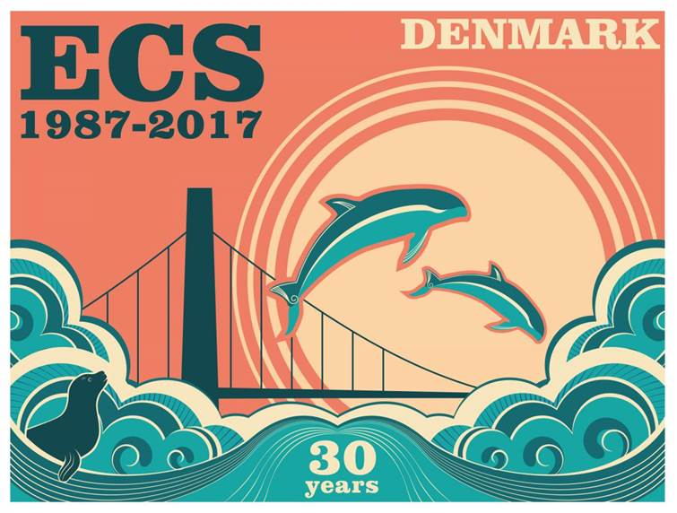
Denmark, Middelfart 1-3 May 2016
Student grant request form
Due to the uncertainty about the final budget of the forthcoming ECS conference, the assigning of student grants is still to be determined. This form enables you to sign up for a grant and applicants will be notified to each applicant personally by March 2017. Student grants will be allocated based on the information provided by applicants in this form. Please send the form to ecs-17organising@au.dk no later than 20 February 2017.
Please be aware that you can only apply for either a student or a travel grant, not both.
Name
E-mail
Country
Student rank | Bachelors |  |  |  |  | Masters |  |  |  |  | PhD |  |  |  |  | Other
Institute of affiliation

Supervisor & e-mail
(if applicable)
Conference Submission | Poster |  |  |  | Oral |  |  |  |  | Video |  |  |  |  | None
Other grants received? | No |  |  | Yes |  |  |  | Amount
Subject of submission

Motivation
(max 250 words)

